

SEN Information Report
2026–27
Birchwood Junior School
Forest Skies Federation
“Take off and fly!”
Version control
Policy title | SEN Information Report
Scope | Birchwood Junior School (Forest Skies Federation)
Version | 1.0
Statutory basis | Children and Families Act 2014, s.69; SEND Regulations 2014, reg. 51 and Schedule 1
Approved by | Governing Body & Headteacher of Birchwood Junior School
Date approved | 29.09.2026
Date of next review | September 2027
Published | School website

Introduction
At Birchwood Junior School we recognise that every child is a unique individual with their own strengths, needs and ways of learning. We understand that children develop and learn at different rates, and that not all children learn in the same way or at the same pace.
We are committed to providing an inclusive and supportive learning environment in which every child is valued, their individual needs are understood, and they are given the support and opportunities they need to reach their full potential. Our Golden Thread, ‘Inclusivity for All’, runs through everything we do. We are committed to equality of education and opportunity for all children, irrespective of race, sex, disability, religion or belief, or socio-economic background.
“Take off and fly!”

About this report
This is the SEN Information Report for Birchwood Junior School. It is published under Section 69 of the Children and Families Act 2014 and Regulation 51 and Schedule 1 of the Special Educational Needs and Disability Regulations 2014. It is written for parents and carers, and it sets out what our school can offer a child with special educational needs or a disability: what provision is available, how it is decided upon, and how children and families are supported.
The report is reviewed and updated at least annually, and more frequently if our provision changes. It forms part of Lincolnshire County Council’s SEND Local Offer, which sets out the support available across the county for children and young people aged 0 to 25 and their families. The Lincolnshire Local Offer can be found at www.lincolnshire.gov.uk/send-local-offer.
Birchwood Junior School is part of the Forest Skies Federation. Woodlands Infant and Nursery School and The Lancaster School publish their own SEN Information Reports, which are available on their websites. Where this report refers to federation-wide arrangements, this is stated explicitly.
This report should be read alongside our SEND Policy, Accessibility Plan, Equality Policy, Behaviour Policy, Supporting Pupils with Medical Conditions Policy and Complaints Policy, all of which are published on the school website.
A note on the law as it stands. The Schools White Paper ‘Every Child Achieving and Thriving’ (February 2026) proposes significant changes to the SEND system, including a revised SEND Code of Practice, National Inclusion Standards and Individual Support Plans. These are proposals. They require legislation and are not expected to take effect before 2029. The Children and Families Act 2014 and the SEND Code of Practice 2015 remain in force in full, and this report is written under them.

Key contacts
If you have a concern about your child, your first point of contact should always be your child’s class teacher. They know your child best in school and can respond quickly. If your concern needs more specialist input, the class teacher will involve the SENDCO.
Role | Name | Contact
Headteacher | Mr M Davies | Via the school office
SENDCO | Mrs M Lewis | [SENDCO EMAIL ADDRESS]
Deputy Headteacher | Mr D Beveridge | Via the school office
SEND Governor (Forest Skies Federation) | Mr J Cave | Via the Clerk to the Governing Body

You can contact any of these members of staff through the school office on [SCHOOL TELEPHONE NUMBER] or by emailing [SCHOOL EMAIL ADDRESS]. We operate an open-door approach: if you ask to meet a member of staff, we will arrange an appointment, normally within five school days.

What are special educational needs and disabilities?
The SEND Code of Practice states that a child has special educational needs if they have a learning difficulty or disability which calls for special educational provision to be made for them. Special educational provision means provision that is additional to, or different from, that made generally for other children of the same age in mainstream schools.
A disability is defined by the Equality Act 2010 as a physical or mental impairment which has a long-term and substantial adverse effect on a person’s ability to carry out normal day-to-day activities. Not every child with a disability has special educational needs, and not every child with special educational needs has a disability. Where a child has a disability, we have a duty to make reasonable adjustments so that they are not placed at a substantial disadvantage.
Children with special educational needs may require support in one or more of four broad areas of need:
- Cognition and learning
- Communication and interaction
- Social, emotional and mental health
- Sensory and/or physical needs

These four areas describe the type of support a child may need. They are not labels, and a child’s needs may sit across more than one area or change over time. Further information can be found in the ‘Special Educational Needs and Disability Code of Practice: 0 to 25 years’ (2015), available at www.gov.uk/government/publications/send-code-of-practice-0-to-25.

What kinds of special educational needs do we make provision for?
Birchwood Junior School is a mainstream setting for children aged 7 to 11. We make provision for children with needs across all four broad areas. As a staff team we have many years of experience of supporting children with speech, language and communication needs, autism, ADHD, dyslexia, dyscalculia, cerebral palsy, pathological demand avoidance, attachment difficulties, memory difficulties and global developmental delay.
We do not require a diagnosis before we put support in place. Support is based on a child’s identified needs, not on a label. Equally, a diagnosis on its own does not automatically mean a child has special educational needs: the test is whether they need provision that is additional to or different from that made for their peers.
Admission arrangements for children with SEND are the same as for all other children and are set out in our Admissions Policy. We do not discriminate against children on the grounds of disability, and we will make reasonable adjustments to enable a child with a disability to attend and take part in school life.

How do we identify special educational needs?
A child is identified as having special educational needs if they have a learning difficulty which is significantly greater than that of the majority of their peers, or a disability which prevents or hinders them from making use of the educational facilities provided for their peers, and which as a result calls for special educational provision to be made for them.
The Headteacher and SEND Governor are responsible for overseeing provision for children with SEND. The SENDCO is responsible for co-ordinating day-to-day provision.
We use a graduated approach to decide when a child is having difficulty accessing their learning. Children whose progress or attainment falls significantly outside the range of their peers are monitored to identify possible difficulties. Following discussion with the SENDCO, adapted learning opportunities and teaching approaches are put in place to support progress. If those adaptations do not close the gap, we move through the stages set out in the flowchart below.
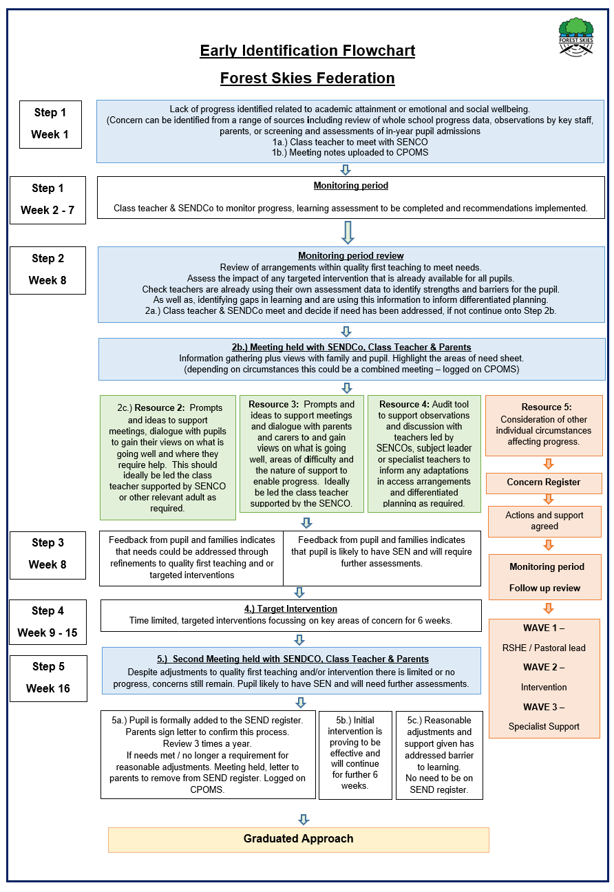
Early Identification Flowchart
Where the early identification process indicates that a child is likely to have special educational needs, we move to the graduated approach: a repeating cycle of Assess, Plan, Do and Review.
Stage | What happens
Assess | Your child’s most recent assessments are reviewed by the class teacher and the SENDCO. The SENDCO completes appropriate observations and assessments to identify the specific area of need, and speaks to your child to gather their views in an age-appropriate way. Any information from outside agencies is considered at this stage.
Plan | Taking the findings into account, we plan the actions for your child. These may include monitoring with reasonable adjustments in place for a term, putting appropriate interventions in place, or adding your child to the SEND register and creating a pupil profile with specific targets. Targets are based on the four areas of need, are informed by your child, and are shared with you.
Do | Staff use a range of strategies to carry out the planned actions. This may include in-class support, an adapted curriculum, reasonable adjustments, small group work, one-to-one work, additional interventions, observations by the SENDCO, and observations or assessments by outside agencies.
Review | Your child’s attainment is reviewed at least once every full term. Progress against targets is reviewed, looking at what has been achieved over the period of the plan and at how well the strategies worked. We then decide, with you, whether your child should remain on the SEND register, whether support needs to increase, or whether your child no longer needs to be on the register.

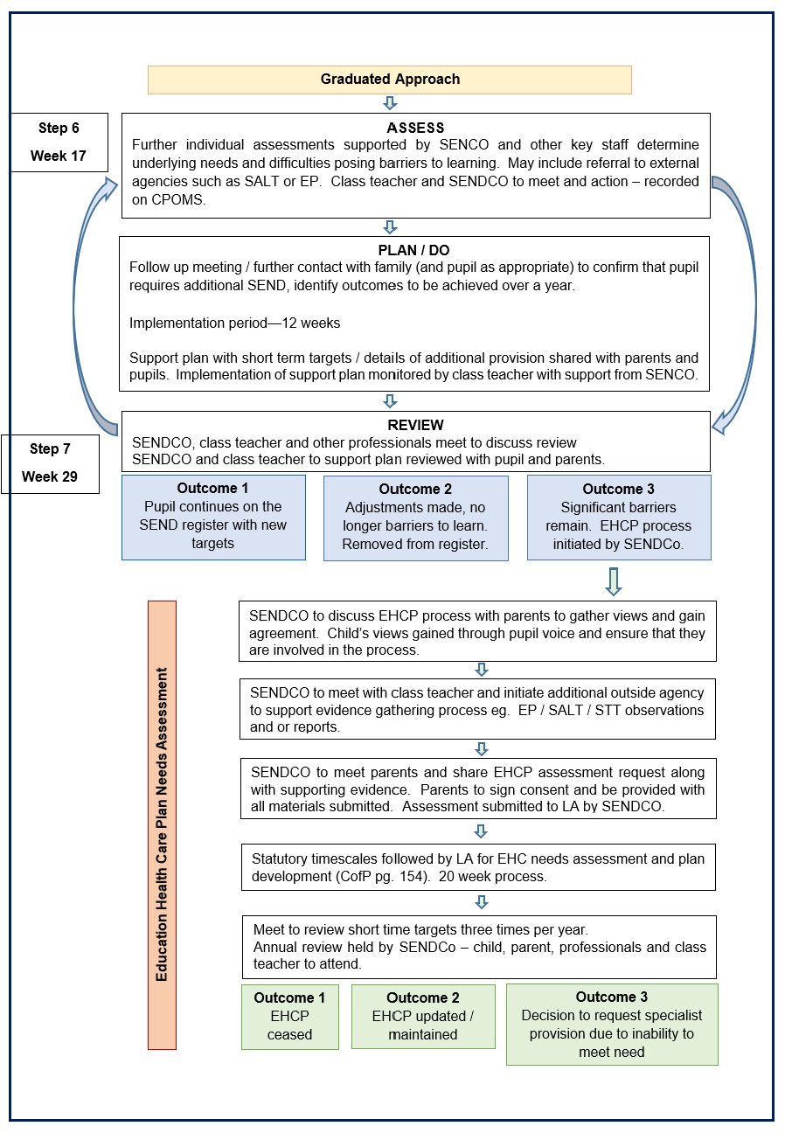
Graduated approach and the Education, Health and Care needs assessment route
We are committed to identifying additional needs at the earliest opportunity and to putting support in place as soon as it is required. As part of this we may carry out additional assessments to build a clearer picture of your child’s strengths and needs. Individual targets are set and reviewed regularly, and your child will be involved in identifying and reviewing their targets wherever this is appropriate to their age and understanding.

What should I do if I think my child has special educational needs?
Please contact the school. In the first instance, speak to your child’s class teacher. If you would prefer, you can ask to speak to the SENDCO or the Headteacher. We will listen to your concerns, tell you what we are already seeing in school, and agree with you what happens next and when we will get back to you.

Will a decision ever be made about my child’s special educational needs without my knowledge?
No. We will always discuss any decision about your child’s needs and provision with you, and with your child where this is appropriate, before it is made. Your views will be recorded and taken into account.
Where we propose to add your child to, or remove your child from, the SEND register, we will meet with you first, explain why, and give you the opportunity to ask questions and share your view. We will confirm the outcome to you in writing. Your written consent is always required before we refer your child to, or share information with, any external agency such as the Educational Psychology Service or Speech and Language Therapy.

Who will support my child in school?
Who | Role and responsibility | Qualifications and experience
Class teachers | Your first point of contact if you have any concern about your child. Class teachers teach your child, assess their attainment, adapt teaching to meet their needs, and make sure your child is safe and happy in school. | All teaching staff hold Qualified Teacher Status. Training and qualifications vary, and all teaching staff undertake the same core SEND training in school, delivered by the SENDCO or by outside agencies.
Teaching assistants and HLTAs | Our teaching assistants and support staff work closely with children, parents and outside agencies, and in partnership with the class teacher and SENDCO, to deliver the provision agreed for your child. | Our teaching assistants hold a range of qualifications including NVQs and degrees, and are a very experienced team, many of whom have worked with children with additional needs in the federation for a number of years. Children with an EHCP requiring one-to-one support have a designated adult each day.
SENDCO | Monitors the progress of every child on the SEND register, sets and reviews targets, monitors the effectiveness of interventions, refers to outside agencies where necessary, and reviews and chairs EHCP review meetings. | Mrs Lewis has completed the National Award for SEN Co-ordination, as required by the SEND Code of Practice.
Headteacher | Line manages the SENDCO and holds them to account for the provision and strategies used to support children. Responsible for ensuring that SEND documentation and policies are up to date and that the SENDCO is maintaining records appropriately. | Mr M Davies — BA (Hons), PGCE, NPQH, MA, CMI.
SEND Governor | The governing body has a named SEND Governor, who meets the SENDCO each term to monitor provision and reports back to the governing body. | Mr J Cave.
Outside agencies | Support the SENDCO in setting targets and in assessing and observing children in school. We work with specialist teachers, educational psychologists, speech and language therapists, occupational therapists, physiotherapists, paediatricians, sensory support teachers and specialist nurses. | Qualifications vary between agencies. All are qualified practitioners in their field.

What training have staff had, and what is planned?
All teaching staff hold Qualified Teacher Status and all staff undertake the same core SEND training in school, delivered by the SENDCO or by external specialists. A number of our teaching assistants hold the ELKLAN speech and language qualification, and our SENDCO has completed the National Award for SEN Co-ordination.
All staff have received training in:
- Safeguarding — annual face-to-face training with weekly updates
- Understanding and managing behaviour — a nurtured approach (Team Teach)
- ADHD awareness
- Working Together Team approaches
- Autism and attachment
- The dyslexia-friendly classroom
- Trauma-informed classroom approaches
- First aid
- Restorative practice

Training needs are identified through the school’s appraisal and monitoring cycle, through the SENDCO’s analysis of the needs on the SEND register, and in response to the needs of individual children joining the school. Where a child arrives with a need we have not supported before, we commission specific training rather than waiting for the annual cycle. Planned training for 2026–27 is set out in the school’s CPD plan and is available on request.

Who else might be involved in supporting my child?
We work with a wide range of external professionals. Involvement from any of these services requires your consent, and we will always discuss a referral with you before it is made.
Service | Role and responsibility
Educational Psychology Service | Educational psychologists assess a child’s special educational needs and support and advise staff. This may relate to specific learning needs or to social and emotional needs.
Specialist Teaching Team | Visits school to help identify specific areas of difficulty in a child’s learning, including dyslexia. They work with children individually to assess needs and suggest strategies for staff to use in class.
Working Together Team | Works with staff to suggest strategies for children experiencing social and communication difficulties, including autism.
Speech and Language Therapy | A team of therapists providing specialist assessment, advice and blocks of therapy for children with speech, vocabulary or communication difficulties.
Physiotherapy | Advises on programmes to be used in school to develop motor control and movement.
Occupational Therapy | Advises on equipment, adaptations and activities to support children’s learning and social development.
Sensory Education Support Team | Offers advice and guidance to teachers working with children with visual, hearing or sensory impairment.
Behavioural Outreach Support Service | Supports and advises mainstream school staff working with children who display challenging behaviour. They meet staff and parents and provide strategies to support children individually in school.
School Nursing Team | Advises and supports the school, including specialist nursing for medical needs and diabetes nursing.
Play therapist | The school has access to a Theraplay therapist who works privately with families to support loss and attachment needs.
Emotional Literacy Support Assistant (ELSA) | A teaching assistant trained to provide emotional and social skills support to children.
Grief and bereavement service | Supports children and families dealing with loss, including the death of a parent or close relative, or where a family member is receiving end-of-life care.
Paediatricians | Doctors specialising in the health and care needs of children. They can also provide a diagnosis where a child may have a medical condition or additional need.
CAMHS (Child and Adolescent Mental Health Services) | Supports children with a range of complex mental and emotional health needs. Families are referred by a medical practitioner.

How will the curriculum be matched to my child’s needs?
All children are taught alongside their peers and have access to the statutory programmes of study set out in the National Curriculum. Class teachers are responsible for adapting teaching, learning opportunities and resources so that every child can access the curriculum and make progress in line with their needs. High-quality inclusive teaching is the first and most important response to a child’s needs; additional intervention supports it but never replaces it.
Where a child is identified as having SEND, they may need provision that is additional to or different from that provided for other children of the same age. The nature and level of that support depends on the individual child. We make reasonable adjustments to our curriculum, teaching approaches and learning environment so that children with SEND can take a full part in school life.
The tables that follow set out the adjustments and provision available at each tier of our graduated response, in each of the first three areas of need. These are examples of what is available; they are not a checklist, and no child receives all of them. Sensory and physical needs are addressed through the accessibility arrangements and external specialist involvement described later in this report.

Cognition and learning
Universal | Universal + | Targeted | Targeted +
Modelling — I do, we do, you do; WAGOLL  Working walls  Alphabet strips, phoneme mats, key word mats  Chunked instructions and information  Sequencing taught as a skill  Checking understanding, e.g. learners repeating instructions back; metacognitive strategies  Visual cues  Recall of, and explicit links to, prior learning  Processing time  Scaffolding, e.g. writing frames  Manipulatives and concrete resources  Visual timetables  IT programs and apps  Whiteboards and pens to support memory  Texts reflecting interest and age range  Text presented clearly (font size, font type, background)  Dual coding, e.g. diagrams and pictures to add meaning  Reading-aloud expectations considered carefully  Memory techniques taught and modelled  Copying from the board minimised  Distractions reduced | Individual workstation  Hover support  Additional time to complete tasks  Recording options and demand considered, including use of technology  Small group pre-teaching of vocabulary or skills  Small group over-learning to embed class teaching  Small group recall of prior learning  Interventions for specific skills, e.g. phonics; reading, writing and maths; precision teaching  Specific strategies and resources: iPads for recording and playing back voice; colourful semantics; coloured overlays and paper; memory games; speech-to-text software; read-aloud software | Pupil profile  One-page profile  Bespoke timetable  Accelerated Reader Plus groups  Fresh Start phonics  One-to-one or small group pre-teaching  One-to-one or small group over-learning  One-to-one recall of prior learning  Bespoke interventions  Specific strategies and resources: reader pens; dictaphones; assistive technology | Personalised EHCP targets  Specialist intervention and educational psychologist involvement  Local authority and special school outreach support

Our intervention offer
Phonics · Pinny time · Fresh Start · Pre-teaching · Over-learning · Times tables support · Handwriting support · Precision teaching

Communication and interaction
Universal | Universal + | Targeted | Targeted +
Effective listening guidelines  Learning behaviours explicitly taught, with reminders given  Cues for active listening  Speech rate considered  Key words and vocabulary explicitly taught and emphasised  Processing time given — waiting ten seconds for a response  Visual prompts, e.g. Widgit symbols  Objects of reference  Clear, simple, adapted instructions  Delivery of information slowed down to allow processing  Language modelled and scaffolded  Cueing in by name  Learners encouraged and shown how to seek clarification  Talking buddies and partners  Recall strategies used in lessons  Flexible groupings | Echoing responses, repeating sentences back using correct grammatical structures  My turn, your turn — the child copies sentences modelled by an adult  Bespoke recall support  Speech and language assessment completed in school, with interventions delivered regularly for a fixed period  Hover support; instructions repeated and rephrased  Classroom position considered — proximity to an adult and visibility of the board  Stammering guidance implemented  Specific strategies and resources: comic strip conversations; social stories; emotion and five-point scales | Pupil profile  One-page profile  Personalised word mats and vocabulary spider diagrams  Use of technology  Personalised ways to ask for support  Personalised visuals, e.g. visual timetable, now and next, toilet card  Personalised visuals to support routines and transitions  Additional support to follow instructions  Tasks adapted and broken into smaller steps  Objects of reference to support transitions  Additional support at breaktimes  Individual workstation  Bespoke timetable including brain, sensory and movement breaks and daily interventions  Educational psychologist involvement  Speech and language therapy involvement and ongoing intervention  Specific sensory equipment  Planned progression over time — working alongside others, with an adult, then with peers  Specific interventions: Lego-based therapy; play intervention; ELSA | Personalised EHCP targets  Specialist intervention and educational psychologist involvement  Speech and language therapist, specialist advisory service or other professional with expertise in speech, language and communication needs involved  Bespoke speech and language interventions as directed by specialists  Virtual Autism Hub support  Local authority and special school outreach support

Our intervention offer
Bespoke speech sounds intervention · Bespoke speech and language intervention · Lego-based therapy · Play intervention · ELSA

Social, emotional and mental health
Universal | Universal + | Targeted | Targeted +
Clear behaviour expectations  Relational approach  Strengths and interests identified  Growth mindset  Listening to the child  Cueing in by name  Calming music where appropriate  Positive language and unconditional positive regard  Clear time limits for work  Seating arrangements considered, e.g. for attention, focus and good role models  A safe place to store belongings  Transitions considered  Tools and equipment clearly labelled and accessible  Chunked instructions supported with visual cues  Calm, clear communication  Instructions, routines and rules kept short, precise and positive  Emotional literacy  Specific strategies and resources: feelings wheel; time to talk; worry box; movement breaks; restorative practice; circle time; fidget resources used during breaks | Additional adult support  Individual workstation  Bespoke emotional literacy work  Individual visual timetable  Now and next, or now, next, then  Hover support  Visual timer, e.g. sand timer  Time out  Learners taught to use post-it notes or a whiteboard for questions and ideas  Teaching personalised where possible to reflect the child’s interests  Soft start — settling time in the morning  Additional movement breaks, legitimised, e.g. by doing a job  Specific strategies and resources: emotions scale; social groups; ELSA support; circle of friends | Pupil profile  One-page profile  Bespoke timetable  Named key adults  Regular check-ins  Local authority and special school outreach support  Educational Psychology Service involvement  Behaviour plan  Individual risk assessment  Specific strategies and resources: playing for purpose; Lego-based therapy; socially speaking; bespoke emotions scale; sensory circuit | Personalised EHCP targets  Specialist intervention and educational psychologist involvement  CAMHS involvement  Local authority and special school outreach support

Our intervention offer
Social groups and play intervention (board games) · Circle of friends · ELSA · Play for purpose · Socially speaking · Recognising emotions · Zones of regulation · Behavioural activation · Cognitive restructuring · Graded exposure · Emotionally based school avoidance pathway · Lego therapy

What if my child has significant medical needs?
If your child has a medical condition, an individual healthcare plan will be written jointly with you, your child and any medical professionals involved, in line with our duty under Section 100 of the Children and Families Act 2014 and our Supporting Pupils with Medical Conditions Policy.
All staff hold basic first aid training and four members of staff hold advanced first aid training. Staff are trained to support children with diabetes, cerebral palsy, anaphylaxis and epilepsy, and have previously supported children requiring bolus feeding.
Where a child has a diagnosed allergy, we follow the statutory guidance on allergy safety in schools and the school’s allergy arrangements, which include individual allergy management plans, staff training in the recognition and treatment of anaphylaxis, and spare adrenaline auto-injectors held on site.
If you wish your child to receive medication during the school day, you will be asked to complete and sign the school’s medicines consent form. All medicines are stored in a locked medical cupboard and are signed for each time they are administered.

What support is there for my child’s behavioural needs?
We take a positive, relational approach to behaviour. Behaviour in and out of the classroom is recognised and rewarded, and all staff contribute to this. After a behaviour incident the child will talk with a member of staff and have time to reflect, to discuss the reasons behind what happened and to consider what they could do differently.
We recognise that behaviour is a form of communication and that persistent difficulties with behaviour may indicate an unmet need. Where a child is finding behaviour difficult, the class teacher will seek the advice of the SENDCO. If further support is needed, we will meet with you and agree next steps together. An individual behaviour plan and a risk assessment will be drawn up, setting out the strategies that will be used, and these will be reviewed regularly. We may seek support from the Educational Psychology Service or the Behavioural Outreach Support Service, who will meet with parents and observe the child in school.
Our Behaviour Policy applies to all children, and we make reasonable adjustments to it for children with SEND. Before any decision to suspend or permanently exclude a child with SEND, we consider whether the behaviour is related to an unmet need and whether the support in place has been appropriate, in line with the Department for Education’s statutory guidance on suspension and permanent exclusion and our Suspension and Permanent Exclusion Policy.

How do we support emotional and social development?
Supporting children’s emotional and social development is a core part of our provision, not an add-on. Every child has access to a trusted adult in school, to our PSHE and RSHE curriculum, and to the pastoral routines of the school day.
Additional pastoral support available to children with SEND includes work with our Emotional Literacy Support Assistant, social and communication groups, nurture and check-in arrangements, restorative conversations, and referral to specialist services including CAMHS and the Lincolnshire Centre for Grief and Loss where this is appropriate.
We know that children with SEND can be more vulnerable to bullying. Bullying of any kind is not tolerated at Birchwood Junior School. Our Anti-Bullying and Behaviour Policies set out how we prevent bullying, how children and parents can report it, and how we respond. Prevention work includes explicit teaching about difference and disability through the PSHE curriculum, staff supervision of less structured times such as breaks and lunchtimes, and providing children who need it with a safe, supervised alternative at those times. Any report of bullying involving a child with SEND is recorded and monitored by the SENDCO as well as the pastoral team.

How will my child be included in activities outside the classroom, including school trips?
All children are included in all parts of the school curriculum, and we aim for all children to take part in school trips, residentials and extra-curricular activities alongside their peers. We provide the support needed to make this successful.
A risk assessment is carried out before any off-site activity. Parents are involved at this stage so that we can be confident a child’s needs will be met. In the unlikely event that it is considered unsafe for a child to take part in a particular activity, we will discuss this with you and provide an alternative activity covering the same curriculum areas in school. Additional cost is never a reason for a child with SEND to be excluded from an activity.

How accessible is the school environment?
We are able to support children with physical disabilities. The school has a hygiene suite with a changing bed and hoist, two accessible toilets and ramped access throughout the site.
We have strong links with a local special school for children with physical disabilities, who provide staff training and direct support for our children and families. All staff supporting a child with a physical disability receive relevant training in moving and handling, feeding and intimate care.
Our Accessibility Plan, published on the school website, sets out how we will increase the extent to which disabled pupils can participate in the curriculum, improve the physical environment of the school, and improve the availability of information to disabled pupils in accessible formats. It is reviewed every three years as required by Schedule 10 of the Equality Act 2010.

How will I know how well my child is progressing?
We assess children’s progress in reading, writing and mathematics each term. This enables class teachers to identify quickly any child who is not making expected progress or who is not working at age-related expectations. We also use the multiplication tables check and standardised assessments to build a fuller picture of progress.
Children who are not making expected progress are identified at termly pupil progress meetings between class teachers, subject leaders and the senior leadership team. Every child is discussed. Staff consider what the child has achieved and whether they are on track to meet their targets, and identify children who need further support or challenge.
Any child may receive additional support or challenge as a result of assessment data. This does not automatically mean they will need a pupil profile or a place on the SEND register. Their progress will be monitored closely by the SENDCO through the whole-school provision map and they will receive intervention specific to their area of need.
For children on the SEND register, progress towards individual targets is reviewed at least termly, and formally with you three times a year. Where a child has an Education, Health and Care Plan, an annual review is held and chaired by the SENDCO.

What opportunities will there be for me to discuss my child’s progress?
You will have the opportunity to attend parents’ evenings three times a year, where you will be given a copy of your child’s pupil profile and have the opportunity to discuss it. | You will receive a written report on your child at the end of each academic year.
We operate an open-door approach. You can request a meeting with a member of staff working with your child at any point in the year, and we will arrange an appointment, normally within five school days. | You will be invited to meetings with outside agencies and to review meetings.

How will my child be involved and able to contribute their views?
Review meetings  Your child’s views are gathered before every review meeting. They are asked what they think has worked well, what they feel they need to work on next, and for their input into reviewing provision and setting targets. | SENDCO discussions  As part of regular monitoring, the SENDCO talks to your child to check that they are happy and feel safe and supported in school, and asks them to suggest how we could help further. There are opportunities for informal check-ins throughout the school day.
One-page profiles  A one-page profile is a simple summary of what is important to your child and how they want to be supported. It is written with your child. | Interventions  Your child’s class teacher plans specific interventions to support them. During these, your child is asked to feed back on the activity — whether it is helping, how they learn best, and what they find difficult.

Children with special educational needs are treated fairly and respectfully and are fully supported in the classroom and around school by all staff. Your child’s targets are always shared with them and they are always involved in reviewing them and agreeing next steps. Child-friendly targets are used so that children can access their own next steps, and visual timetables, social stories and learning prompts are used to support independence and progress.

What if my child makes limited progress?
If, despite targeted support, regular review and involvement from outside agencies, your child:
- makes limited progress; and/or
- is working at a level well below that expected for their age; and/or
- has extensive medical or physical needs

it may be appropriate to consider requesting an Education, Health and Care needs assessment from Lincolnshire County Council. This is the route to higher-need provision, and the process can be discussed with the SENDCO directly.
An EHC needs assessment is requested by the school with your consent, and you are also entitled to request one yourself. The local authority has 20 weeks from the date of the request to complete the process and, where an Education, Health and Care Plan is issued, to finalise it. You can get free, impartial advice about this process at any stage from Liaise, Lincolnshire’s SEND Information, Advice and Support Service.

How will the school support my child to join the school or move on to a new setting?
Transition programmes, additional to the planned whole-school transition days, are developed to meet the individual needs of each child. The Forest Skies Federation has close links with local nursery and secondary schools, and staff move between the federation sites, so they are already familiar to the children. This supports a smooth transition.
Transition days and activities are planned between every year group, with additional resources such as photographs, brochures, website tours and extra visits available for children who need them. The aim is that children settle quickly and feel safe, happy and secure in their new environment.
If your child transfers to us from another school, the SENDCO or Headteacher will speak to their previous school so that we understand and can meet their needs as quickly as possible.
For the move to secondary school:
- Secondary schools attend our Year 6 open evening and parents’ evenings to showcase their provision and answer questions.
- Towards the end of Year 5 and the beginning of Year 6, parents and children are advised to visit the full range of secondary schools to decide which best suits their child. The SENDCO can help you make contact with secondary school SENDCOs.
- From Year 5, children may take part in sports afternoons or science workshops at local secondary schools. In Year 6 there are further transition days.
- We run a transition club for children identified as having a high level of need around the move to secondary school, covering organisation, making new friends, navigating routes to school and preparing to leave the junior school.
- Outside agencies, including Autism Outreach and the Educational Psychology Service, support children and families through the move from Key Stage 2 to Key Stage 3.
- The SENDCO of your child’s secondary school is always invited to their final review meeting in Year 6, so that targets, strategies and provision can be shared directly.

How do we evaluate the effectiveness of our SEND provision?
Publishing what we offer is not the same as knowing whether it works. We evaluate the effectiveness of our provision in the following ways:
- Every intervention has a defined start point, a target and an exit measure. Entry and exit data are recorded on the whole-school provision map so that we can see whether an intervention closed the gap it was intended to close.
- The SENDCO analyses the progress and attainment of children on the SEND register against that of their peers each term, and reports this to the senior leadership team at pupil progress meetings.
- Monitoring activity — learning walks, work scrutiny and pupil conferencing — includes a specific focus on how well children with SEND access adapted teaching in the classroom.
- Attendance, suspension and behaviour data for children with SEND are monitored separately and compared with the whole-school picture.
- Children with SEND and their parents are asked for their views at least annually, and the findings are reported to governors.
- The SEND Governor meets the SENDCO each term to monitor provision and reports to the full governing body.
- The SENDCO reports annually to governors on the effectiveness of SEND provision, including what has been changed as a result of the previous year’s evaluation.

Where evaluation shows that provision is not having the intended impact, it is changed. Our SEND priorities for the current year are set out in the School Development Plan.

What provision is there for more able children?
The Forest Skies Federation offers a range of opportunities for children who are particularly able in a specific area, whether academic, sporting or musical. Where your child is recognised as working at greater depth or showing particular talent, we will discuss this with you and may share information about local clubs and activities that could develop their skills further.
Opportunities in school include writing workshops, author visits, visits to places in the local community, sports coaching, athletics events, swimming galas and peripatetic music tuition.
Being more able is not a special educational need, and children in this group are not placed on the SEND register. This section is included because parents frequently ask about it. A child can, of course, be both highly able and have a special educational need, and where that is the case both are planned for.

How can I access support for myself and my family?
Liaise is Lincolnshire’s SEND Information, Advice and Support Service (SENDIASS). It provides free, confidential and impartial information, advice and support to children and young people aged 0 to 25 with SEND and to their parents and carers. Liaise is independent of the school. You can contact them on 0800 195 1635 or at liaise@lincolnshire.gov.uk, or through www.liaiselincolnshire.org.uk.
Lincolnshire County Council’s SEND Local Offer at www.lincolnshire.gov.uk/send-local-offer brings together information about education, health and social care services, activities, transport and how to get help, in one place.

What if I have a concern or a complaint about SEND provision?
Please tell us. Most concerns are resolved quickly by talking to the right person, and we would much rather hear about a problem early than late.
- Step 1 — Speak to your child’s class teacher. They will respond, normally within five school days.
- Step 2 — If the matter is not resolved, contact the SENDCO, who will arrange to meet you.
- Step 3 — If you remain dissatisfied, contact the Headteacher.
- Step 4 — If the matter is still unresolved, it can be raised formally under the Forest Skies Federation Complaints Policy, which is published on the school website and sets out the stages and timescales that apply.

At any point you can seek free, impartial advice from Liaise. Some matters fall outside the school’s complaints procedure:
- Complaints about the content of an Education, Health and Care Plan, or about a decision not to assess or not to issue a plan, are matters for Lincolnshire County Council. You have a right of appeal to the First-tier Tribunal (Special Educational Needs and Disability), and you can also use the local authority’s disagreement resolution and mediation services.
- Claims of disability discrimination by the school are made to the First-tier Tribunal (Special Educational Needs and Disability). These must generally be made within six months of the alleged discrimination.
- If you have exhausted the school’s complaints procedure and believe the governing body has acted unlawfully or unreasonably, you can complain to the Department for Education.

Terms you may come across
Schools use a lot of abbreviations. If you come across one that is not explained here, please ask a member of staff — you will not be the first person to ask.
Term | What it means
SEN / SEND | Special educational needs / special educational needs and disabilities.
SENDCO | Special Educational Needs and Disabilities Co-ordinator — the member of staff who co-ordinates support for children with SEND.
SEN register | The school’s record of children receiving SEN support.
SEN support | Support that is additional to or different from that given to other children of the same age, provided by the school.
Graduated approach | The repeating cycle of Assess, Plan, Do and Review used to work out what support a child needs.
EHCP | Education, Health and Care Plan — a legal document issued by the local authority setting out a child’s needs and the provision required to meet them.
EHC needs assessment | The local authority’s assessment to decide whether a child needs an EHCP. It takes up to 20 weeks.
Pupil profile / one-page profile | A short document describing a child’s strengths, needs, targets and the strategies that work for them.
Provision map | The school’s record of all the additional support being provided across the school and its impact.
ARE | Age-related expectations — the standard expected for a child of that age.
Reasonable adjustment | A change the school makes so that a disabled child is not put at a substantial disadvantage. This is a legal duty under the Equality Act 2010.
ELSA | Emotional Literacy Support Assistant.
EP | Educational psychologist.
SALT | Speech and language therapy or therapist.
OT | Occupational therapy or therapist.
CAMHS | Child and Adolescent Mental Health Services.
Liaise / SENDIASS | Lincolnshire’s free, impartial SEND Information, Advice and Support Service for families.
Local Offer | The local authority’s published information about services available for children and young people with SEND across Lincolnshire.

Other useful contacts
These organisations are independent of the school. Contact details change; if a number does not work, please let the school office know so that we can update this report.
Organisation | Contact
Liaise — Lincolnshire SEND Information, Advice and Support Service | 0800 195 1635 · liaise@lincolnshire.gov.uk · www.liaiselincolnshire.org.uk
Lincolnshire SEND Local Offer | www.lincolnshire.gov.uk/send-local-offer
Lincolnshire Parent Carer Forum | www.lincspcf.org.uk
IPSEA — Independent Provider of Special Education Advice | www.ipsea.org.uk
Council for Disabled Children | councilfordisabledchildren.org.uk
Children’s Therapy Services (Lincolnshire) | 01522 514814
Lincolnshire Children’s Services | 01522 554673
Lincolnshire Centre for Grief and Loss | 01522 546168
PAACT — autism support | paactsupport@hotmail.co.uk
ADHD Support, Lincoln | 01522 539939 · lincoln.adhd@btconnect.com
British Dyslexia Association | 0333 405 4555 · www.bdadyslexia.org.uk

If you have any further questions or comments about SEND provision at Birchwood Junior School, please do not hesitate to contact us.

