
BIRCHWOOD JUNIOR SCHOOL
Forest Skies Federation

Behaviour Policy
and Statement of Behaviour Principles
Persistent · Consistent · Insistent

Document control
Field | Detail
Policy | Behaviour Policy and Statement of Behaviour Principles
School | Birchwood Junior School, Forest Skies Federation
Status | Supersedes the Sept 2025 policy on adoption
Approved by | Governing Body
Date adopted | 01.09.2026
Last reviewed on | 01.09.2025
Next review due by | Annually, and following any significant incident
Linked policies | Child Protection & Safeguarding Policy  Positive Handling Policy  Anti-Bullying Policy  Suspension & Permanent Exclusion Policy  SEND Policy  Equality & Accessibility Policy  Mobile Phone / Acceptable Use Policy  Staff Code of Conduct

Contents
1. Aims 3
2. Legislation, statutory requirements and statutory guidance 3
3. Definitions 4
4. Bullying 4
5. Restorative practice 6
6. Roles and responsibilities 6
7. School behaviour curriculum 7
8. Responding to behaviour 8
9. Serious sanctions 11
10. Responding to misbehaviour from pupils with SEND 12
11. Supporting pupils following a sanction 13
12. Pupil transition 13
13. Training 13
14. Monitoring arrangements 13
15. Links with other policies 14
Appendix 1: Written statement of behaviour principles, values and aims 15
Appendix 2: Restorative practice 15
Appendix 3: School rules, the 5 R’s & 2 C’s, and our values 17
Appendix 4: The 3 Stages of Support (Ladder of Intervention) 18
Appendix 5: Forest Skies Federation training log (example) 19
Appendix 6: Individual Behaviour Plan (IBP) & Risk Assessment 20
Appendix 7: Attention signals and routines — ‘Ready to Listen’ 21

1. Aims
This policy aims to:
- Create a positive culture that promotes excellent behaviour, ensuring that all pupils have the opportunity to learn in a calm, safe and supportive environment.
- Establish a whole-school approach to maintaining high standards of behaviour that reflect the values of the school.
- Outline the expectations and consequences of behaviour.
- Provide a consistent approach to behaviour management that is applied equally to all pupils.
- Define what we consider to be unacceptable behaviour, including bullying and discrimination.

1.1 Our behaviour culture: the PCI principles
Behaviour at Birchwood is the foundation of safety, wellbeing and learning. Our culture is built on three principles that every adult applies, every day. We call them the PCI principles:
P  Persistent  We never let it go. Every behaviour below our standard is addressed — every time — and every consequence is followed up. We follow through, always. | C  Consistent  Every adult responds in the same way, using the same stepped script and the same language, so children meet the same expectations in every room, with every adult. | I  Insistent  We hold the line warmly and never negotiate the standard, because we believe every child can meet it — delivered through relationships and positive scripting, never through force.

The PCI principles run through everything in this policy — how we recognise good behaviour, how we respond to misbehaviour, the language we use, and how we follow up. When our practice is persistent, consistent and insistent, there are no grey areas: children always know the expectation, and they always know why.

1.2 Our three values
Our expectations are framed through our three school values. Every reward, conversation and consequence is linked back to them:
- Aspirational Mindset — we show resilience, recover from setbacks and keep striving to improve. “Keep going, keep growing.”
- Academic Excellence — we focus, take pride in our work and produce our best. “Do your best work every time.”
- Personal Development — we are kind and respectful, make good choices and take responsibility. “Be the best version of you.”
What these values look like for children is captured in our twelve “I…” statements, displayed in every classroom (Appendix 3).

2. Legislation, statutory requirements and statutory guidance
This policy is based on legislation and advice from the Department for Education (DfE) on:
- Behaviour in schools: advice for headteachers and school staff
- Searching, screening and confiscation: advice for schools
- The Equality Act 2010
- Keeping Children Safe in Education
- Suspension and permanent exclusion from maintained schools, academies and pupil referral units in England, including pupil movement
- Use of reasonable force in schools
- Supporting pupils with medical conditions at school
It is also based on the Special Educational Needs and Disability (SEND) Code of Practice. In addition, this policy is based on:
- Section 175 of the Education Act 2002, which outlines a school’s duty to safeguard and promote the welfare of its pupils.
- Sections 88 to 94 of the Education and Inspections Act 2006, which require schools to regulate pupils’ behaviour and publish a behaviour policy and written statement of behaviour principles, and give schools the authority to confiscate pupils’ property.
- DfE guidance explaining that maintained schools must publish their behaviour policy online.

3. Definitions
Misbehaviour is defined as:
- Disruption in lessons, in corridors between lessons, and at break and lunchtimes
- Non-completion of classwork or homework
- Poor attitude
- Incorrect uniform
Serious misbehaviour is defined as:
- Repeated breaches of the school rules
- Any form of bullying
- Sexual violence, such as rape, assault by penetration, or sexual assault (intentional sexual touching without consent)
- Sexual harassment, meaning unwanted conduct of a sexual nature (including sexual comments, jokes or taunting; physical behaviour such as interfering with clothes; and online sexual harassment)
- Vandalism
- Theft
- Fighting
- Smoking
- Racist, sexist, homophobic or discriminatory behaviour
Possession of any prohibited items. These are: knives or weapons (including toys and replicas); alcohol; illegal drugs; stolen items; tobacco and cigarette papers; fireworks; pornographic images; and any article a staff member reasonably suspects has been, or is likely to be, used to commit an offence, or to cause personal injury to, or damage to the property of, any person (including the pupil).

4. Bullying
Bullying is defined as the repetitive, intentional harming of one person or group by another person or group, where the relationship involves an imbalance of power. Bullying is therefore deliberately hurtful, repeated (often over a period of time), and difficult to defend against.
Type of bullying | Definition
Emotional | Being unfriendly, excluding, tormenting
Physical | Hitting, kicking, pushing, taking another’s belongings, any use of violence
Prejudice-based and discriminatory (racial, faith-based, sexist, homophobic/biphobic, transphobic, disability-based) | Taunts, gestures, graffiti or physical abuse focused on a particular characteristic (e.g. gender, race, sexuality)
Sexual | Explicit sexual remarks, display of sexual material, sexual gestures, unwanted physical attention, comments about sexual reputation or performance, or inappropriate touching
Direct or indirect verbal | Name-calling, sarcasm, spreading rumours, teasing
Cyber-bullying | Bullying that takes place online, such as through social networking sites, messaging apps or gaming sites

In line with the Equality Act 2010, we eliminate unlawful discrimination, harassment and victimisation; advance equality of opportunity; and foster good relations between those who share a protected characteristic and those who do not. Under the Children Act 1989, a bullying incident will be addressed as a child protection concern where there is reasonable cause to suspect that a pupil is suffering, or is likely to suffer, significant harm; where this is the case, staff report their concerns to the Local Authority’s safeguarding team. This policy is closely linked with our Safeguarding and Child Protection Policy, our Staff Code of Conduct, and the school’s vision, aims and values.

4.1 Bullying prevention
Preventing and raising awareness of bullying is essential. Through assemblies and PSHE lessons, pupils regularly discuss what bullying is — and what it is not, such as two friends falling out or a one-off argument. An annual Anti-Bullying Week further raises awareness. E-safety is embedded in the curriculum, with information for parents in newsletters, on the website and through workshops. Pupils are taught to tell an adult if they are concerned that someone is being bullied.

4.2 School rules
Our school rules are promoted in assemblies and displayed throughout school, and sit beneath our three values. Through pupils following them and staff persistently, consistently and insistently reinforcing them, bullying is significantly reduced. Our rules are:
- We show respect for everyone and everything by being kind with our words and actions.
- We listen and follow instructions, by listening to adults and each other.
- We are honest by telling the truth.
- We try our best by showing resilience.
- We set a good example, because we are proud to be a member of our community.

4.3 Reporting and responding to bullying
All cases of alleged bullying are reported to the Headteacher/Deputy Headteacher or a senior member of staff. The class teacher or a senior leader first establishes the facts and builds an accurate picture over time, speaking to those involved and to witnesses, parents and pupils as appropriate. All incidents are recorded on CPOMS. Where an allegation is upheld, a senior leader uses a restorative approach with the parties together; the perpetrator(s) understand the impact of their actions and apologise without reservation, and both parties are clear that any repeat is unacceptable. Parents of both parties are informed. If the situation does not improve, the school meets parents to agree clear expectations, and any further incidents lead to intervention (including outside agencies), monitoring, support and proportionate sanctions until the bullying has stopped.

5. Restorative practice
Restorative practice is a way of working with conflict that focuses on repairing the harm that has been done, involving all parties. At Birchwood, restorative approaches are built on values that separate the person from the behaviour; they promote accountability and seek to repair harm. All staff receive regular training in restorative practice and preventative principles, and the inclusion team provides coaching and mentoring for ECTs and new staff as part of induction. This is supported by our pastoral offer, including the SoSafe programme, Commando Joe’s, Art Therapy and ELSA-trained support staff. The restorative principles and five-step process are set out in Appendix 2, and our Behaviour Reflection Think Sheet structures the same conversation on paper.

6. Roles and responsibilities

6.1 The governing board
- Reviewing and approving the written statement of behaviour principles (Appendix 1).
- Reviewing this behaviour policy in conjunction with the Headteacher.
- Monitoring the policy’s effectiveness.
- Holding the Headteacher to account for its implementation.

6.2 The Headteacher
- Reviewing and approving this policy in conjunction with the governing body, and giving due consideration to the statement of behaviour principles (Appendix 1).
- Ensuring the school environment encourages positive behaviour and that staff deal effectively with poor behaviour.
- Monitoring that the policy is implemented consistently with all groups of pupils, and that all staff understand and uphold the PCI principles and behavioural expectations.
- Providing new staff with a clear induction into the school’s behavioural culture, and appropriate training in behaviour management and the impact of SEND and mental health needs on behaviour.
- Ensuring this policy works alongside the safeguarding policy to offer pupils both sanctions and support.
- Ensuring behaviour data is reviewed regularly so that no group of pupils is disproportionately impacted.

6.3 Teachers and staff
Staff are the single most important factor in a consistent culture. Staff are responsible for:
- Creating a calm and safe environment and establishing clear, consistent boundaries.
- Implementing this policy and the agreed stepped script (section 8.4) persistently, consistently and insistently — with every child, every time.
- Communicating expectations, routines, values and standards through teaching behaviour and in every interaction with pupils.
- Modelling expected behaviour and positive relationships, and using positive recognition and ‘over-talk’ to catch children getting it right.
- Providing a personalised approach to the specific behavioural needs of particular pupils.
- Recording behaviour incidents promptly on CPOMS.
- Challenging pupils to meet the school’s expectations.
The senior leadership team (SLT) will support staff in responding to behaviour incidents.

6.4 Parents and carers
Parents and carers, where possible, should get to know the behaviour policy and reinforce it at home; support their child in following it; inform the school of any changes in circumstances that may affect behaviour; discuss concerns with the class teacher promptly; take part in any pastoral work following misbehaviour; and raise concerns with the school directly while continuing to work in partnership. When a child joins Birchwood, parents sign a home–school behaviour agreement. The school builds positive relationships with families by keeping them informed and working in collaboration to tackle behavioural issues.

6.5 Pupils
During their induction into the behaviour culture, pupils are made aware of the expected standard of behaviour; their duty to follow the policy; the school’s key rules and routines; the rewards they can earn and the consequences they will face; and the pastoral support available to them. Pupils are supported to meet the standards, with repeated induction where appropriate, and are asked to give feedback on their experience of the behaviour culture. Extra support and induction are provided for mid-phase arrivals.

7. School behaviour curriculum
Pupils are explicitly taught how to behave and why it matters, through our personal development and PSHE curriculum. Pupils are expected to:
- Behave in an orderly and self-controlled way.
- Show respect to members of staff and to each other.
- In class, make it possible for all pupils to learn.
- Move quietly and calmly around the school.
- Treat the school buildings and property with respect.
- Wear the correct uniform at all times.
- Accept consequences when given.
- Refrain from behaving in a way that brings the school into disrepute, including outside school or online.
These expectations are taught through our PSHE curriculum lenses — citizenship and personal development, the 5 R’s and 2 C’s (Appendix 3), inductions and transitions, the Stay Safe partnership, SoSafe, the school nurse, Commando Joe’s, ELSA and Art Therapy. Where appropriate and reasonable, adjustments may be made to routines so that all pupils can meet behavioural expectations (see section 10).

7.1 Mobile phones
No personal mobile devices are permitted within classrooms or areas with children (staff excepted, in lockers, and for DSL/SLT). The school provides GDPR-regulated devices for media use. Pupils are not permitted to have mobile phones with them on-site; these must be handed into reception before the start of the day, locked securely during the day, and collected at the end. The school accepts no liability for personal devices children bring to school.

8. Responding to behaviour

8.1 Classroom management
Teaching and support staff set the tone for positive behaviour. Applying the PCI principles, they will: create and maintain a stimulating environment; display the behaviour curriculum or classroom rules; and develop positive relationships — including greeting pupils at the door, establishing clear and consistent routines, communicating expectations in more than words, highlighting good behaviour through peripheral praise and ‘over-talk’, concluding the day positively and starting each day afresh, having a plan for low-level disruption, and using positive reinforcement.
8.1.1 Gaining attention — our whole-school signal
All staff use a consistent attention signal so that learning time is maximised and transitions are calm, purposeful and efficient. A consistent whole-school approach reduces unnecessary teacher talk, creates predictable routines, and helps pupils understand exactly what is expected. In line with the DfE’s Early Career Framework, staff routinely remind pupils of established rules and routines so that pupils are increasingly able to follow them independently.
Birchwood’s agreed whole-school attention signal is the 3-2-1 countdown, supported by a raised hand. Every adult uses the same words:
The only words we use
“I need all eyes on me and conversations finished by the time I have counted down to one. 3… 2… 1.”

When staff begin the countdown, pupils stop conversations, finish their current activity safely, and prepare to listen. By the time the countdown reaches “one”, every pupil is focused and ready for instruction. This routine is explicitly taught, modelled and practised regularly until it is automatic.
8.1.2 The STAR routine
Once the countdown reaches “one”, all pupils demonstrate the STAR routine. This gives a single, consistent whole-school expectation of what successful listening looks like:
 | STAR | What this looks like
S | Sit Silent | Pupils stop talking immediately, remain still, and are ready to listen.
T | Track the Speaker | Pupils keep their eyes on the adult (or the person speaking) and follow the instruction being given.
A | Ask and Answer Questions | Pupils listen carefully, think about what has been said, and contribute appropriately when invited.
R | Respect | Pupils show respect to the speaker and to others by listening without interrupting and demonstrating positive learning behaviours.

STAR is explicitly taught, modelled and practised throughout the school so that it becomes an automatic response whenever the attention signal is used. Staff reinforce it consistently through praise, reminders and positive recognition. The ‘Ready to Listen’ poster (Appendix 7) is displayed in every classroom.
8.1.3 Signal, Pause, Insist
Staff use the evidence-informed Signal, Pause, Insist approach to secure attention consistently and respectfully. This is the clearest daily expression of the ‘Insistent’ principle: we hold the line calmly and simply do not proceed until every child is ready.
- Signal — every adult uses the 3-2-1 countdown, supported by a raised hand or agreed visual cue. The signal is never assumed: it is explicitly taught, rehearsed and revisited throughout the year until all pupils respond automatically. A consistent signal reduces the need for adults to raise their voices.
- Pause — staff deliberately pause before speaking. This ‘take-up time’ gives pupils the opportunity to finish conversations, redirect their attention and prepare to listen, and allows the adult to scan the room and establish eye contact. Effective adults do not compete with pupil conversations; they remain calm and continue only once full attention has been secured.
- Insist — adults calmly insist that every pupil responds before teaching continues. Wherever possible this is achieved non-verbally — through eye contact, presence and patient waiting — rather than repeated verbal reminders. Teaching does not resume until every pupil is demonstrating STAR. Positive reinforcement is used to recognise pupils who respond promptly and model the expectation for others.
Insistence in this policy always means quiet, unwavering expectation — never raised voices, escalation, or any form of physical means.

8.2 Safeguarding
The school recognises that changes in behaviour may indicate that a pupil is in need of help or protection. We will consider whether a pupil’s misbehaviour may be linked to them suffering, or being likely to suffer, significant harm, and where this may be the case we follow our Child Protection and Safeguarding Policy and consider whether pastoral support, an early help intervention or a referral to children’s social care is appropriate.

8.3 Responding to good behaviour
Positive behaviour is our expectation and our focus. When a pupil meets or goes beyond the expected standard, staff recognise it clearly and fairly, reinforcing our culture. Positive behaviour is recognised through:
- Shout Outs — linked directly to our three values and awarded by any member of the school community, including children.
- House Points — tokens earned for demonstrating our values, with a house celebration each term.
- Verbal praise and ‘over-talk’ — noticing and naming the behaviour we want to see, out loud.
- Celebration Assemblies and awards — Golden Jumper, Headteacher Award, Star of the Term, Writer/Reader/Mathematician of the Week, and MSA Positive Play.
- Communication home — phone calls or written correspondence and shout-out cards to celebrate success with families.
- Positions of responsibility — such as Sports Ambassadors, School Councillors, Mini Police and Attendance Champions.

8.4 Responding to misbehaviour — our stepped script
When a pupil’s behaviour falls below the standard, staff respond to restore a calm, safe environment and prevent recurrence. Applying the PCI principles, every adult uses the same stepped script, delivered calmly and, where possible, privately. This gives pupils a predictable, fair experience and always a chance to put things right. The stepped script operates within Stage 1 of our 3 Stages of Support (Appendix 4).
Step | What every adult says | What the adult does
Step 1 Reminder | “___, that is a reminder — you are not making good choices right now. I know you can show [value]. Thank you.” | A quiet, private reminder. Then step away and look to catch them getting it right.
Step 2 Friendly warning | “___, this is your friendly warning. The choices you are making are not showing [value]. If this continues, the consequence will be time paid back in reflection. You can turn this around now.” | Name the value and the exact consequence; give them room to choose again.
Step 3 Consequence | “___, you are continuing to make the wrong choice. This is now a consequence — time paid back in reflection — due to [value-linked reason].” | Apply it calmly and record it on CPOMS. The conversation is completed in reflection, restoratively.

De-escalation techniques, including pre-arranged scripts and phrases, are used to prevent further difficulty. All pupils are treated equitably, with any contributing factors identified and taken into account. When giving a consequence, staff also consider what support could help the pupil meet expectations in future. The school may use one or more of the following: a verbal reminder of expectations; a written account of behaviour; work completed at break, lunch or home; reflection at break, lunch or after school; loss of a privilege or prized responsibility; school-based community service; referral to the pastoral team; a letter or phone call home; a behaviour contract or Individual Behaviour Plan (IBP); a standards report; removal from the classroom to the pastoral space; suspension; or, in the most serious circumstances, permanent exclusion. Personal circumstances are taken into account and decisions are made case by case, with regard to perceived fairness.

8.5 Reasonable force
Reasonable force covers a range of interventions that involve physical contact with pupils. All members of staff have a duty to use reasonable force, in the following circumstances, to prevent a pupil from: causing disorder; hurting themselves or others; damaging property; or committing an offence.
Incidents of reasonable force must:
Always be used as a last resort.
Be applied using the minimum amount of force, and for the minimum amount of time possible.
Be used in a way that maintains the safety and dignity of all concerned.
Never be used as a form of punishment.
Be recorded and reported to parents.

When considering using reasonable force, staff should, in considering the risks, carefully recognise any specific vulnerabilities of the pupil, including SEND, mental health needs or medical conditions. Staff who may need to use positive handling are trained in Team Teach, and this training is kept up to date. This section should be read alongside the Federation’s Positive Handling Policy, which contains the full detail.

8.6 Searching, screening and confiscation
Any prohibited items (listed in section 3) found in a pupil’s possession will be confiscated and will not be returned. We will also confiscate any item that is harmful or detrimental to school discipline; these will be returned after discussion with senior leaders and parents, if appropriate. Searching and screening are conducted in line with the DfE’s latest guidance.

8.7 Off-site misbehaviour
Sanctions may be applied where a pupil misbehaves off-site when representing the school — taking part in a school-organised or school-related activity, travelling to or from school, wearing school uniform, or otherwise identifiable as a pupil of our school — and at any other time if the misbehaviour could have repercussions for the orderly running of the school, poses a threat to another pupil, or could adversely affect the school’s reputation. Sanctions are only given on school premises or where the pupil is under the lawful control of a staff member.

8.8 Online misbehaviour
The school can issue sanctions for online misbehaviour when it poses a threat or causes harm to another pupil, could have repercussions for the orderly running of the school, adversely affects the school’s reputation, or where the pupil is identifiable as a member of the school.

8.9 Suspected criminal behaviour
If a pupil is suspected of criminal behaviour, the school makes an initial assessment of whether to report the incident to the police, endeavours to preserve any relevant evidence, and — if reporting — the Headteacher, a member of SLT or the pastoral lead makes the report. The school will not interfere with police action but may continue its own investigation and sanctions where these do not conflict. Where a report is made, the DSL makes a tandem referral to children’s social care if appropriate.

8.10 Zero-tolerance approach to sexual harassment and sexual violence
The school ensures all incidents of sexual harassment and/or violence are met with a suitable response and never ignored. Pupils are encouraged to report anything that makes them uncomfortable, however ‘small’. The school’s response is proportionate, considered, supportive and decided case by case, with clear processes for responding to a report and for carrying out risk assessments to determine whether to manage the incident internally, refer to early help, refer to children’s social care, or report to the police.

8.11 Malicious allegations
Where a pupil makes an allegation against a member of staff, or against another pupil, that is shown to have been deliberately invented or malicious, the school will consider whether to discipline the pupil in accordance with this policy. In all cases where an allegation is determined to be unsubstantiated, unfounded, false or malicious, the school — in collaboration with the Local Authority Designated Officer (LADO), where relevant — will consider whether the pupil who made the allegation is in need of help, or whether the allegation may have been a cry for help, in which case a referral to children’s social care may be appropriate. The school will also consider the pastoral needs of staff and pupils accused of misconduct. Please refer to our Child Protection and Safeguarding Policy for more information on responding to allegations against staff or other pupils.

9. Serious sanctions
Birchwood follows the Forest Skies Federation Ladder of Intervention (Appendix 4), applied in accordance with the Lincolnshire Ladder of Intervention. Strategic discussions are recorded on CPOMS in the Discussion Log.

9.1 Detention and reflection
The Headteacher and Deputy Headteacher are authorised to administer after-school detentions. Teaching and support staff are authorised to assign children to reflection during break and lunch, supervised by a member of SLT or the pastoral team. When imposing a detention, the school considers whether doing so would compromise the pupil’s safety, conflict with a medical appointment, prevent the pupil getting home safely, or interrupt caring responsibilities, and decides whether to inform parents.

9.2 Removal from the classroom
In response to serious or persistent breaches, the school may remove a pupil from the classroom for a limited time, decided by the pastoral/SLT team, with activities targeted towards restorative practice. Removed pupils continue to receive meaningful education under supervision. Removal is a serious sanction, used only after other strategies have been attempted unless the behaviour is so extreme as to warrant immediate removal, and is used to restore order, maintain safety, allow learning to continue in a managed environment, or allow the pupil to regain calm. Pupils are supervised by the pastoral team, for a maximum of one school day, and are not removed for prolonged periods without the explicit agreement of the Headteacher. Pupils are reintegrated as soon as it is appropriate and safe, with support to meet the expected standards. Parents are informed the same day. All incidents of removal are recorded on CPOMS. For pupils frequently removed, the school considers alternatives such as pastoral meetings, use of teaching assistants, short-term standards reports, long-term behaviour plans (IBP), and multi-agency assessment.

9.3 Suspension and permanent exclusion
The school can use suspension and permanent exclusion in response to serious incidents or persistent poor behaviour that has not improved following in-school sanctions and interventions. The decision to suspend or exclude is made by the Headteacher and only as a last resort. Please refer to our Suspension and Permanent Exclusion Policy for more information.

10. Responding to misbehaviour from pupils with SEND

10.1 Recognising the impact of SEND on behaviour
The school recognises that a pupil’s behaviour may be impacted by a special educational need or disability, although not every incident of misbehaviour will be connected to their SEND — decisions are made case by case. When dealing with misbehaviour from pupils with SEND, the school balances its legal duties: taking reasonable steps to avoid substantial disadvantage to a disabled pupil (Equality Act 2010); using best endeavours to meet the needs of pupils with SEND (Children and Families Act 2014); and securing the provision in any EHC plan. We anticipate likely triggers and put support in place — for example planned movement breaks, adjusted seating, adjusted uniform requirements, staff training in conditions such as autism, and use of regulated separation spaces for timed, structured breaks (see IBP).

10.2 Adapting sanctions for pupils with SEND
When considering a consequence for a pupil with SEND, the school takes into account whether the pupil was unable to understand the rule or instruction, was unable to act differently at the time as a result of their SEND, or is likely to behave in a particular way due to their SEND, and then assesses whether it is appropriate to use a consequence and whether reasonable adjustments are needed.

10.3 Unidentified SEND
The pastoral team or SENDCO may evaluate a pupil who exhibits challenging behaviour to determine whether they have underlying needs that are not being met, seeking advice from specialist teachers, an educational psychologist or medical practitioners where necessary, and working with parents to plan and review support.

10.4 Pupils with an EHC plan
The provisions set out in an EHC plan must be secured and the school co-operates with the local authority and other bodies. Where there is a concern about the behaviour of a pupil with an EHC plan, the school contacts the local authority and, if appropriate, may request an emergency review.

11. Supporting pupils following a sanction
Following a consequence, the school considers strategies to help pupils understand how to improve their behaviour and meet expectations. This includes reintegration meetings, daily contact with the pastoral team, and an IBP and Risk Assessment in the event of persistent misbehaviour or a suspension. Crucially, time in reflection is restorative: a member of staff sits with the pupil and, using restorative practice, helps them understand why they are there — linked to our three values — and how to put it right. Our aim is to build three things:
- Resilience — recovering from the setback, trying again, and understanding that one wrong choice does not define them.
- Self-regulation — naming the feeling behind the behaviour and rehearsing a calmer response for next time.
- Independence — owning the choice and the plan to put it right, so the pupil can self-correct without an adult managing it.

12. Pupil transition
The school supports incoming pupils to meet behaviour standards through an induction process that familiarises them with the policy and wider culture. To ensure a smooth transition to the next year, pupils have transition sessions with their new teacher(s) and staff hold transition meetings. Information related to pupil behaviour may be transferred to relevant staff at the start of the term or year so that support continues without a gap.

13. Training
All behaviour is a means of communication and has a cause and a purpose. As a federation we recognise our legal duty under the Equality Act 2010 to prevent pupils with a protected characteristic from being disadvantaged, and our approach may be differentiated to meet the needs of the pupil. As part of their induction, and as part of ongoing CPD, staff receive regular training on managing behaviour, including:
- The proper use of restraint — Team Teach.
- The needs of the pupils at the school.
- How SEND and mental health needs impact behaviour.
- Restorative practice and preventative principles.
A staff training log can be found in Appendix 5.

14. Monitoring arrangements

14.1 Monitoring and evaluating school behaviour
The school collects data on behavioural incidents (including removal from the classroom); attendance, permanent exclusion, suspension and reflection; use of pupil support, off-site directions and managed moves; incidents of searching, screening and confiscation; and anonymous surveys of staff, pupils, governors and other stakeholders on their experience of the behaviour culture. Data is analysed each half term by the Headteacher and SENDCO and reported to the governing body, from a variety of perspectives including school level, age group, individual staff member, time of day/week/term, and protected characteristic. The school uses this analysis to make sure it is meeting its duties under the Equality Act 2010. Small changes in behaviour may indicate an underlying safeguarding concern and are recorded on CPOMS to build a picture, with early intervention and support offered to the family.

14.2 Monitoring this policy
This behaviour policy is reviewed by the Headteacher and full governing body at least annually, or more frequently if needed to address findings from behaviour data. The written statement of behaviour principles (Appendix 1) is reviewed and approved by the full governing body annually.

15. Links with other policies
This behaviour policy is linked to the following policies:
- Child Protection and Safeguarding Policy
- Suspension and Permanent Exclusion Policy
- Positive Handling Policy
- Anti-Bullying Policy
- Mobile Phone / Acceptable Use Policy
- Staff Code of Conduct
- SEND Policy
- Equality & Accessibility Policy

Appendix 1: Written statement of behaviour principles, values and aims
- Every pupil understands they have the right to feel safe, valued and respected, and to learn free from the disruption of others.
- All pupils, staff and visitors are free from any form of discrimination.
- Staff and volunteers set an excellent example to pupils at all times, applying the PCI principles — persistent, consistent and insistent.
- Rewards, consequences and reasonable force are used consistently by staff, in line with the behaviour policy.
- The behaviour policy is understood by pupils and staff.
- The Suspension and Permanent Exclusion Policy explains that exclusions will only be used as a last resort, and outlines the processes involved.
- Pupils are helped to take responsibility for their actions through restorative practice, building resilience, self-regulation and independence.
- Families are involved in behaviour incidents to foster good relationships between the school and pupils’ home life.
The governing board also emphasises that violence or threatening behaviour will not be tolerated in any circumstances. This written statement of behaviour principles is reviewed and approved by the Forest Skies Federation governing body annually.

Appendix 2: Restorative practice
Principles of restorative practice
- Restoration — the primary aim is to address and repair harm.
- Voluntary — participation is voluntary and based on informed choice.
- Neutrality — processes are fair and unbiased towards participants.
- Safety — processes ensure the safety of all participants and create a safe space to express feelings and views about the harm caused.
- Accessibility — processes are non-discriminatory and available to all those affected.
- Respect — processes are respectful to the dignity of all participants.
The five steps of restorative practice
- Tell the story — what has happened? Start from the beginning.
- Thoughts and feelings — what were/are you thinking? What were/are you feeling?
- Ripples of harm — who has been harmed, and how? What has been the most difficult thing for you?
- Needs — what do you need in order to find closure and move forward?
- What next — what do you think will make things better? What needs to happen?
Our Behaviour Reflection Think Sheet structures the same conversation on paper, linked to our three values, and is signed by staff and pupil:
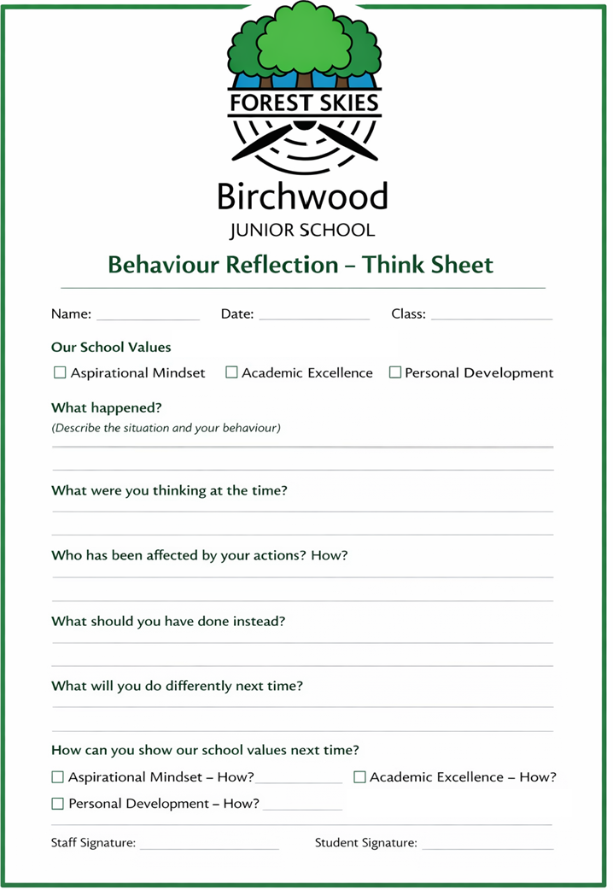

Appendix 3: School rules, the 5 R’s & 2 C’s, and our values
Our twelve “I…” statements show children what each value looks like every day:
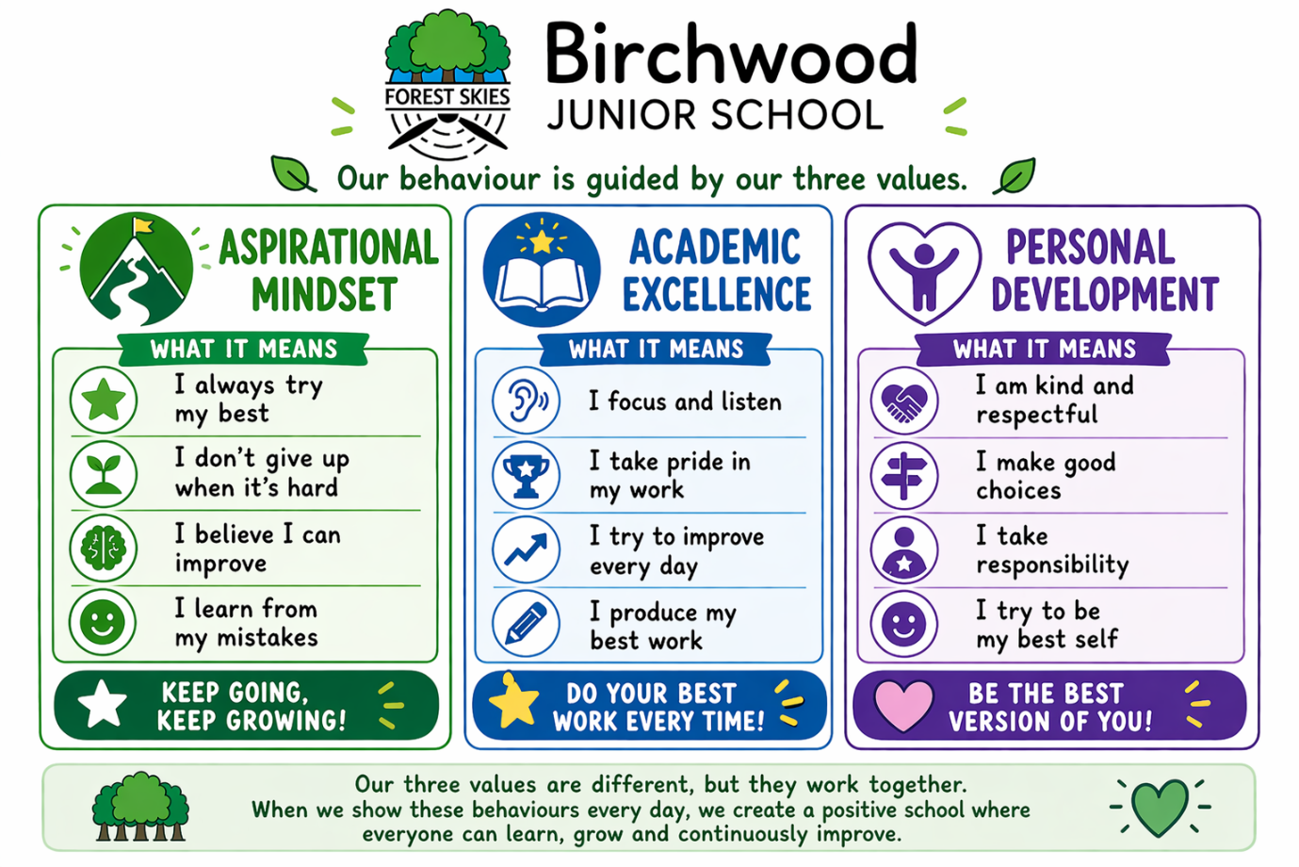
The 5 R’s & 2 C’s
- Rights — everybody at Forest Skies Federation has the right to learn, teach and be part of a friendly, calm, safe and respectful school.
- Responsibilities — we all care for ourselves, others, our belongings, our school and our environment — listening, helping, trying our best, being polite, honest and punctual, and looking after each other.
- Routines — clear communication, movement and safety routines protect our rights and encourage responsibility (hands up without calling out, quiet learning voices, walking safely, lining up sensibly, adhering to e-safety, positive play).
- Respect — everybody has the right to be respected, and the responsibility to respect the rights of others, to be co-operative and self-controlled, and to respect our environment, equipment and resources.
- Choices and Consequences — everybody has the right and responsibility to make their own choices but to accept the resulting consequences. Positive choices are promoted at all times; a clear explanation is given of the range of choices; and consequences are consistent, fair and relative to the action, in line with this policy.

Appendix 4: The 3 Stages of Support (Ladder of Intervention)
Our stepped script (section 8.4) operates within Stage 1. Physical intervention is not part of this ladder except as set out in the note below.
Stage | Behaviour (not an exhaustive list) | Supportive measure | Exemplar dialogue
Stage 1 | Talking when an adult is talking; fiddling; calling out  Disrupting others; not getting on with learning  Moving around without permission  Causing upset through name-calling or similar | Restorative practice principles applied  Reminder → friendly warning → second friendly warning (the stepped script)  Class teacher to inform parent/carer; any missed learning completed at the next break or lunchtime  Failure to act on supportive measures → see Stage 2 | “I can see that you are finding … tricky, so why don’t you …”  “Can I help you with …”  “I am so proud that you managed to …”
Stage 2 | Persistent refusal to carry out instructions or continued low-level disruption  Hitting/hurting with intent; biting; throwing objects; swearing  Persistent refusal to come into class; damaging property  Persistent excluding of peers; persistent refusal to participate | Restorative practice principles applied  Headteacher/class teacher to inform parent/carer depending on severity  A one-off Stage 2 behaviour results in missing the next break and/or lunchtime  Repeated Stage 2 behaviours result in further missed breaks following discussion with SLT  Failure to act → see Stage 3. All incidents recorded on CPOMS | “Take a step back …”  “When you are calm and ready we can begin to resolve …”  “I can see that you are not ready to …”
Stage 3 | Serious damage to property; theft  Physical assault against a pupil or adult  Verbal abuse/threatening behaviour against a pupil or adult  Bullying; racist abuse; sexual misconduct  Carrying knives or other weapons | If behaviour is dangerous to the child, peers or staff, physical intervention will be used to maintain safety (see Reasonable Force, 8.5)  Forest Skies Federation Ladder of Intervention followed, in accordance with the Lincolnshire Ladder of Intervention  Strategic discussions recorded on CPOMS in the Discussion Log  All Stage 3 incidents recorded on CPOMS | Clear support suggestions as to how the child can modify their behaviour for the better

Note on physical intervention
At any stage, if a member of staff conducts a Dynamic Risk Assessment (DRA), physical intervention may be used to keep the child, other children and staff safe.
An IBP and Risk Assessment will be completed after every physical intervention.
Any small changes in behaviour (for example, those listed at Stage 1) may be indicative of an underlying safeguarding concern and will be recorded on CPOMS at the end of a week to build a picture. Early intervention and support will be made available to the family at Stage 1, 2 or 3.

Appendix 5: Forest Skies Federation training log (example)
Training received | Date completed | Trainer / organisation | Staff member(s) | Review date
Behaviour Hub | 17.04.2022 – present | DfE Behaviour Hub | M Davies; R Stock; J Jamieson | December 2022
Behaviour Hub | 05.05.2023 | Behaviour Hub / R Stock | All Birchwood Junior School staff | N/A
Team Teach (Level 1) | 24.04.2025 | Team Teach | All Birchwood Junior School staff | April 2027
Whole School Behaviour and Culture | 03.09.2025 | Birchwood Junior School / M Davies | All Birchwood Junior School staff | January 2026

Appendix 6: Individual Behaviour Plan (IBP) & Risk Assessment
An Individual Behaviour Plan and Risk Assessment are completed for any pupil following persistent misbehaviour, a suspension, or any physical intervention, and are reviewed regularly with parents. The IBP maps a graduated set of behaviour descriptors to planned proactive and re-active adult responses; the linked Risk Assessment records known triggers, pro-active control measures and residual risk. Both are written to the Federation’s standard, uniform format and signed in agreement by the Headteacher, parent/carer, SENDCO and class teacher/TA.
IBP — structure (summary of the approved template)
Level | Behaviour descriptor | Planned adult response
1 — Green | Engaging in learning; responding positively to peers and adults | Proactive: short tasks, timers, planned breaks, own workstation and visual timetable, scaffolded play, check-in/debrief.
2–3 — Amber | Signalling that support is needed; disengaging; distraction and avoidance | Talk time (Now & Next); scaffolded tasks and repeat-back; timed brain break with reminders of the behaviour contract.
4–5 — Red | Rising tension; disruption; persistent talking over adults; refusal | Behaviour-contract vocabulary (Stop–Think–Breathe); guided route to a safe space; structured silent time; ‘Now’ task owed back per policy.
6 — Unsafe | Behaviour placing the pupil, peers or adults at risk | Following a Dynamic Risk Assessment, Team Teach strategies including physical intervention may be used to keep everyone safe. Recorded and reported; IBP/Risk Assessment reviewed.

The full Risk Assessment template records, for each hazard: the level of risk; known triggers; pro-active control measures and actions to be taken; residual risk; and the monitoring arrangements. It is shared with parents, signed in agreement, and reviewed each term (or earlier if incidents require an immediate review).

Appendix 7: Attention signals and routines — ‘Ready to Listen’
The poster below is displayed in every classroom at Birchwood. It sets out the 3-2-1 countdown, the STAR routine that pupils are expected to demonstrate, and the Signal–Pause–Insist sequence that every adult follows (see section 8.1). One signal, one set of words, every classroom, every time.
The poster is designed to be accessible to every pupil. Each element of STAR is conveyed through four independent cues — a symbol, a letter, a colour and short first-person text — so that no pupil is reliant on reading alone. It uses plain, literal language, a dyslexia-friendly typeface with generous line spacing, a low-glare background, and colour is never the sole means of conveying meaning. Reasonable adjustments to how a pupil demonstrates STAR (for example additional processing time, a personal visual prompt, or an agreed alternative to sustained eye contact) are made in line with the pupil’s Individual Behaviour Plan and section 10 of this policy. The expectation remains the same for every child; the support to meet it is adjusted.
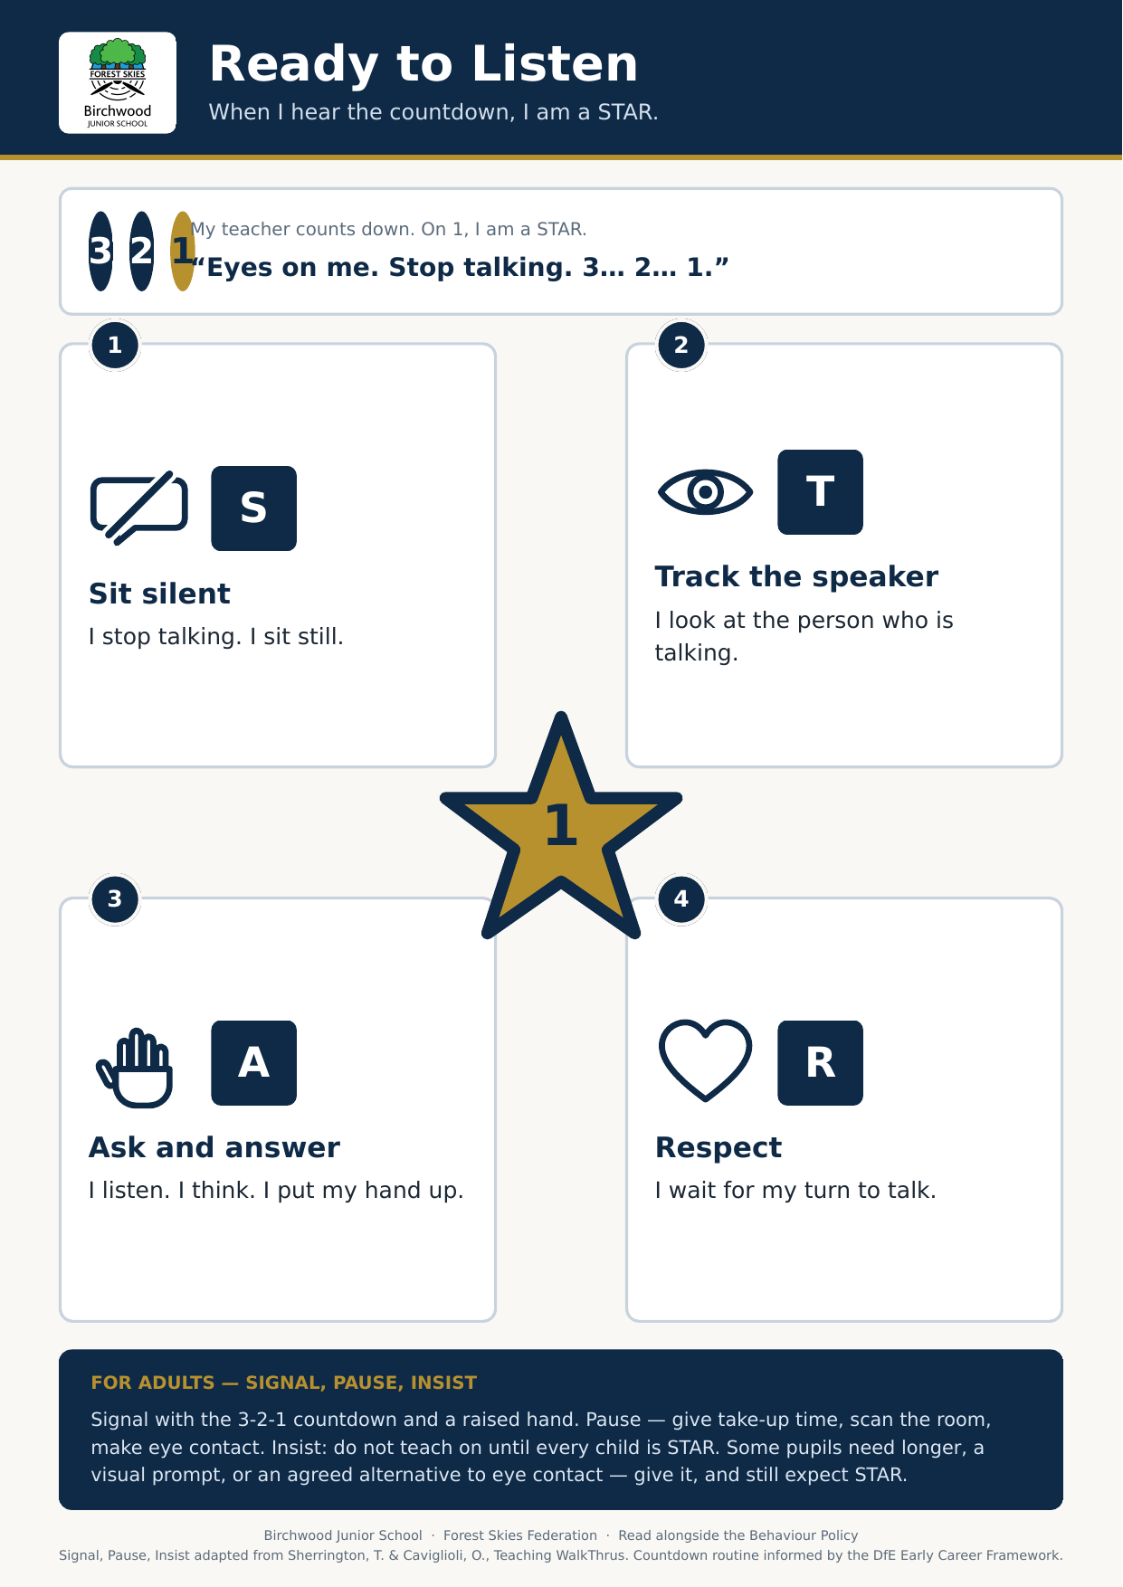
References
- Department for Education, Early Career Framework: Establishing a Positive Climate for Learning (Education Development Trust) — on the importance of consistently reminding pupils of established rules and routines.
- Sherrington, T. & Caviglioli, O., Teaching WalkThrus: Signal, Pause, Insist — an evidence-informed strategy emphasising explicitly teaching and rehearsing attention signals, providing take-up time, and insisting on full attention before instruction begins.

